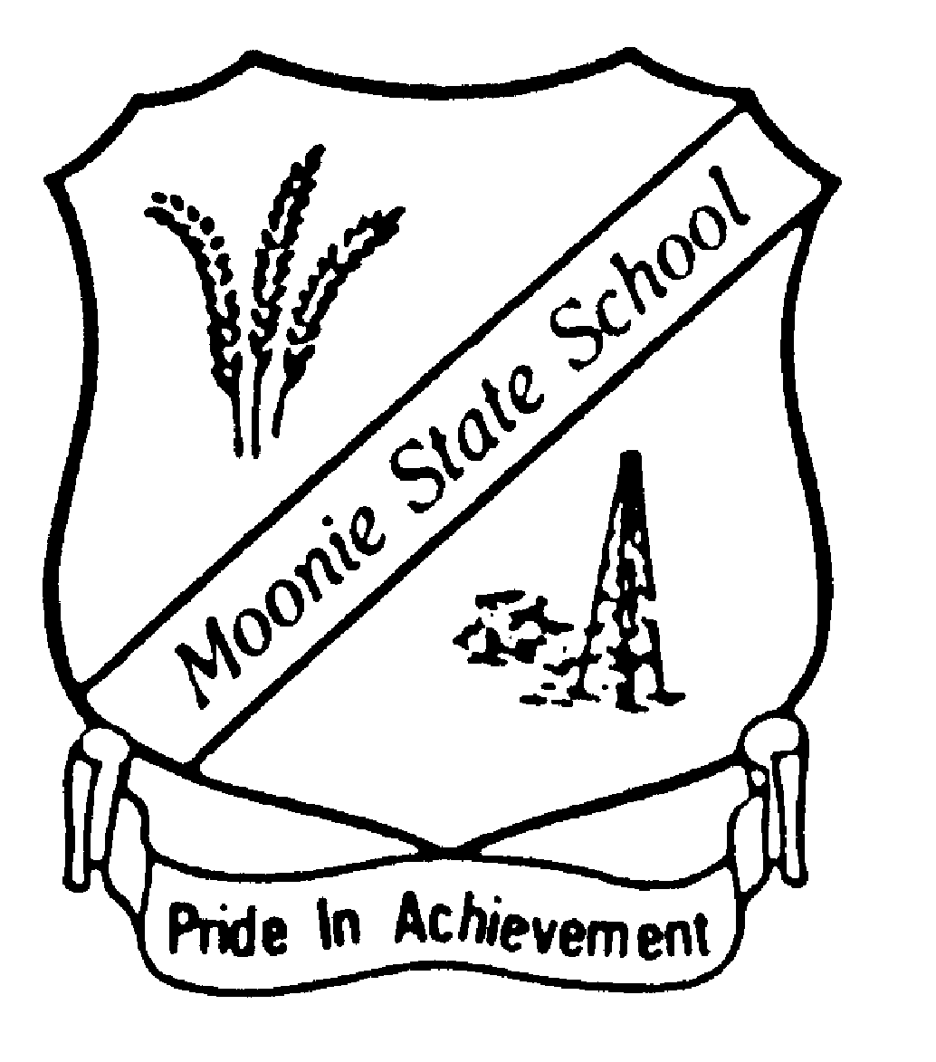

Moonie State School
2025-2028
Student Code of Conduct
Equity and Excellence: realising the potential of every student
Equity and Excellence outlines the government's vision for a progressive, high-performing education system. Equity and Excellence provides clarity for schools about priorities and expectations, with differentiated support targeted to each school's context and needs.
Queensland Department of Education

Purpose

Moonie State School is committed to providing a safe, respectful and structured learning environment for students and staff, where students have opportunities to engage in quality learning experiences and acquire values supportive of their lifelong wellbeing.

This Student Code of Conduct is designed to facilitate high standards of behaviour so that the learning and teaching in our school can be effective and students can participate positively within our school community.

Our school motto is Pride in Achievement and our Student Code of Conduct seeks to honour this motto by enabling all students to develop self-respect and integrity through always treating others with respect.

Contact Information

Postal address: Moonie Highway Moonie Qld
Phone: 4665 0133
Email: ajone390@eq.edu.au
jneal60@eq.edu.au
School website address: mooniess.eq.edu.au
Contact Person: Anna Jones

Endorsement

Principal Name: Anna Jones

Principal’s Signature:

Date:

P&C President Name: Mitchel Cameron

President’s Signature:

Date:
Contents

Principal’s Foreword
Learning and Behaviour Statement
Multi-Tiered Systems of Support
Student Wellbeing & Support Network
Consideration of Individual Circumstances
Whole School Approach to Discipline Clear Expectations
Differentiated and Explicit Teaching
Focussed Teaching Intensive Teaching
Acknowledging of Positive Behaviours
Legislative Delegations Legislation
Delegations
Disciplinary Consequences Differentiated Disciplinary Responses
Focussed Disciplinary Responses
Intensive Disciplinary Responses
School Disciplinary Absences
School Policies
Temporary removal of student property
Use of mobile phones and other devices by students
Preventing and responding to bullying
Appropriate use of social media
Restrictive Practices
Critical Incidents
Related Procedures and Guidelines
Resources
Conclusion
APPENDIX 1 -

Moonie State School continues to be highly regarded as a supportive and learner focused school community. Our school community is built on proudly earned high expectations of achievement and behaviour which are supported through traditional family values.
Principal’s Foreword
Through educational excellence, we are committed to nuturing critical thinkers of the future, developed in an educational environment where high expectations of student behaviour are seen as the foundation to all learning.
Moonie State School is an inclusive school that caters for all students and promotes success through the following Positive Behaviour for Learning expectations:


Be Safe

Be Respectful
Be Responsible

These expectations have been used in the development of this Student Code of Conduct with the commitment to building the skills of all of our students to be confident, self reflective and valued community members who can contribute positively to society.
This document provides a collaborative and clear explanation of what we expect from our students and how we will support every student to meet those expectations.

Principal’s Foreword

Learning and Behaviour Statement

At Moonie State School, we believe that all all areas of the school are learning and teaching environments. We consider behaviour not just as a management issue, but as an opportunity for valuable social and emotional learning that supports academic success. Our approach reflects the understanding that students require explicit instruction, modelling, and consistent reinforcement of expected behaviours.

Our Student Code of Conduct supports a safe, respectful, and inclusive learning environment by encouraging positive behaviors, fostering responsibility, and guiding students in making respectful choices. It provides a clear framework for promoting positive interactions, preventing challenges, and responding to behaviors in a way that reinforces growth and learning.
At all times, Moonie State School seeks to reflect the values and behaviour that are acceptable in our society. We maintain a strong connection to the community outside our school fence and promote values that align with respectful, responsible, and safe behaviour. These beliefs shape students’ decisions, behaviour and social practices and underpin a calm and supportive school climate.

We recognise that our school community is diverse and that not all families or students will share the same beliefs about behaviour. These difference enrich our school environment and also offer opportunities for reflection and learning. We welcome open conversations with families and encourage any student or parent to make an appointment with the principal to discuss our school-wide approach to behaviour support and discipline.

At Moonie State School, our behavioural expectations are explicitly taught, modelled, and reinforced across all areas of the school. These expectations are:
- Be Safe – We take care of ourselves and others.
- Be Respectful – We treat others with kindness and speak and act with courtesy.
- Be Responsible – We own our actions, follow instructions, and contribute positively to our school community.

At Moonie State School, expected behaviours are explicitly taught through weekly lessons, daily reminders, and embedded routines. Staff members consistently model and reinforce these behaviours across classroom and non-classroom settings. Behavioural expectations are:
- Introduced at the start of each year and revisited regularly
- Taught through real-life examples, role-play, and class discussions
- Practised during all school activities
- Reinforced through positive acknowledgement, such as verbal praise, class rewards, and certificates

Student Wellbeing and Support Network

Moonie State School offers a range of programs and services to support the wellbeing of students in our school. We encourage parents and students to speak with their class teacher or the principal if they would like individual advice about accessing particular services.

Student learning and wellbeing are inextricably linked — students learn best when their wellbeing is optimised, and they develop a strong sense of wellbeing when they experience success in learning. The student learning and wellbeing framework supports state schools with creating positive school cultures and embedding student wellbeing in all aspects of school life through: 1. Creating safe, supportive and inclusive environment 2. Building the capability of staff, students and the school community and 3. Developing strong systems for early intervention.

Curriculum and pedagogy

Schools build the foundations for wellbeing and lifelong learning through curriculum embedding personal and social capabilities (self-awareness, self-management, social awareness and social management) in the implementation of the P–12 curriculum, assessment and reporting framework.

Schools acknowledge the positive impact that a meaningful relationship between teacher and students can have on students' academic and social outcomes.

Policy and expectations

Within a school community there are specific health and wellbeing issues that will need to be addressed for the whole school, specific students, or in certain circumstances.

Specialised health needs

Moonie State School works closely with parents to ensure students with specialised health needs, including those requiring specialised health procedures, have access to a reasonable standard of support for their health needs whilst attending school or school-based activities.

This means that appropriate health plans are developed and followed for students with specialised health needs, that staff are aware of the student's medical condition and that staff have been trained to support the student's health condition.

Medications

Moonie State School requires parent consent and medical authorisation to administer any medication (including over-the-counter medications) to students. For students requiring medication to be administered during school hours, the school can provide further information and relevant forms.

For students with a long-term health condition requiring medication, parents need to provide the school with a Consent to administer medication at school form signed by the prescribing health practitioner.

Moonie State School maintains a minimum of one adrenaline auto-injector and asthma reliever/puffer, stored in the school's first aid kit to provide emergency first aid medication if required.

The administration of medications to students by school staff is only considered when a prescribing health practitioner has determined that it is necessary or when there is no other alternative in relation to the treatment of a specific health need. Schools require medical authorisation to administer any medication to students (including over-the-counter medications such as paracetamol or alternative medicines).

Mental health

Moonie State School implements early intervention measures for students where there is reasonable belief that a student has a mental health difficulty. This includes facilitating the development, implementation and periodic review of a Student Plan.

Whole School Approach to Discipline

At Moonie State School, we believe that all students have the right to learn in a safe, supportive and inclusive environment, and that all teachers have the right to teach without disruption. Our approach is based on the belief that all students can learn and succeed when provided with a safe, predictable, and inclusive learning environment.

Moonie State School uses Positive Behaviour for Learning (PBL) as the evidence-based framework for supporting student behaviour. PBL is a whole-school approach used consistently across all classrooms, programs, excursions and sporting activities. It provide a structure for preventing behaviour challenges, teaching positive behaviours, and reinforcing expected conduct in a consistent and productive way.

Positive Behaviour for Learning (PBL)
The PBL framework helps us to:
- Analyse and improve student behaviour and learning outcomes
- Use only evidence-based practices that are applied correctly and consistently by all staff
- Build staff capability to sustain a consistent approach to behaviour across the school

Our staff teach and model behavioural expectations in the same way we teach curriculum – with clarity, repetition, feedback, and encouragement. Behaviour is seen as a skill to be learned, not simply managed. Behavioural incidents are treated as opportunities to reteach, support, and reflect.

Staff use the 10 Essential Skills for Behaviour Management as part of our shared practice to promote respectful, safe and responsible behaviour. These skills help us to create calm, positive classrooms where learning is the focus and every child is supported to succeed.

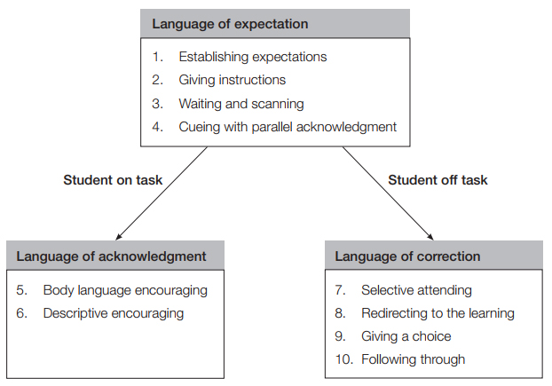

Consideration of Individual Circumstances

At Moonie State School, we are committed to equity and inclusion. When responding to behaviour, we consider each student’s:
- Behaviour history
- Disability and learning profile
- Mental health and wellbeing
- Cultural or religious background
- Home environment or care arrangements

We recognise that behaviour is influenced by a wide range of factors, and we adapt our responses to meet the unique needs of each student. This may include providing:
- Additional support through personalised learning plans
- Behaviour support plans or adjustments
- Guidance from specialist staff or external services
- Flexible or differentiated approaches in the classroom

These supports and interventions are documented and monitored through OneSchool, using tools such as:
- Personalised Learning records
- Support Provisions
- Behaviour Incident reports
- Referral and case management notes
By tracking this information, we can ensure consistency, accountability, and transparency in our approach to student wellbeing and discipline.

Partnerships with Families
We recognise that supporting students is a shared responsibility between the school and home. Strong partnerships with parents and carers help ensure that students receive consistent messages and support across both settings.
We engage families by:
- Sharing our school-wide expectations and behaviour framework
- Communicating regularly about student progress and wellbeing
- Inviting parent input into behaviour plans and support strategies
- Encouraging open dialogue with teachers and school leadership

The language and practices of PBL can be used in the home as well, helping to build a united approach to setting students up for success.
Parents and carers are always welcome to speak with their child’s teacher or arrange a meeting with the principal to discuss any aspect of our behaviour support processes or the Student Code of Conduct.

At Moonie State School, we recognise that each student brings a unique set of experiences and needs to school. Staff take into account a range of individual circumstances—including behaviour history, disability, mental health and wellbeing, religious and cultural background, home environment, and care arrangements—when teaching behaviour expectations, supporting students, and determining appropriate disciplinary responses.
We are committed to equity in our approach, which means that while all students are held to high expectations, the support and responses they receive may differ. This is because treating every student exactly the same does not always result in fair or effective outcomes. For example:
- Some students may require additional support to understand an expectation
- Others may benefit from extra practice to develop a behavioural skill
- For some students, certain consequences may be inappropriate due to past trauma or complex family circumstances

Our staff take all of these factors into account when planning for behaviour instruction and when responding to incidents.

We also respect and protect every student’s right to privacy. School staff are legally and ethically obliged not to discuss the behaviour or disciplinary outcomes of individual students with anyone other than their parent or carer. This includes situations where your child may have been directly affected by another student’s behaviour, such as in incidents of bullying.

While we understand the concerns of students, staff, and families, we ask that our community respects this confidentiality. Please be assured that all incidents are taken seriously and responded to appropriately, in line with our school values and behavioural framework.

If you have concerns about a behavioural incident or how it was managed, we encourage you to make an appointment with the principal to discuss the matter confidentially.

Differentiated and Explicit Teaching

At Moonie State School, we provide differentiated and explicit teaching to support the leaning and behaviour of all students. Our approach is grounded in the belief that every student can succeed when their individual learning needs are understood and addressed through high-quality teaching.

Differentiated teaching at Moonie State School aligns with the Assessment and Moderation Hub’s definition of differention: “planned adjustments to teaching and learning to ensure all students have equitable opportunities to access and engage with the curriculum.”

Teachers differentiate:
- What students learn (content and behavioural expectations)
- How students learn (teaching methods, groupings, supports)
- How they demonstrate learning (responses, tasks, adjustments)

These decisions are informed by data, including behaviour tracking, academic progress, and professional observations. Adjustments are also made to meet legal obligations under the Disability Standards for Education 2005, ensuring reasonable adjustments are made for students with disability.

There are three main layers to differentiation, as illustrated in the diagram below. This model is the same used for academic and pedagogical differentiation.

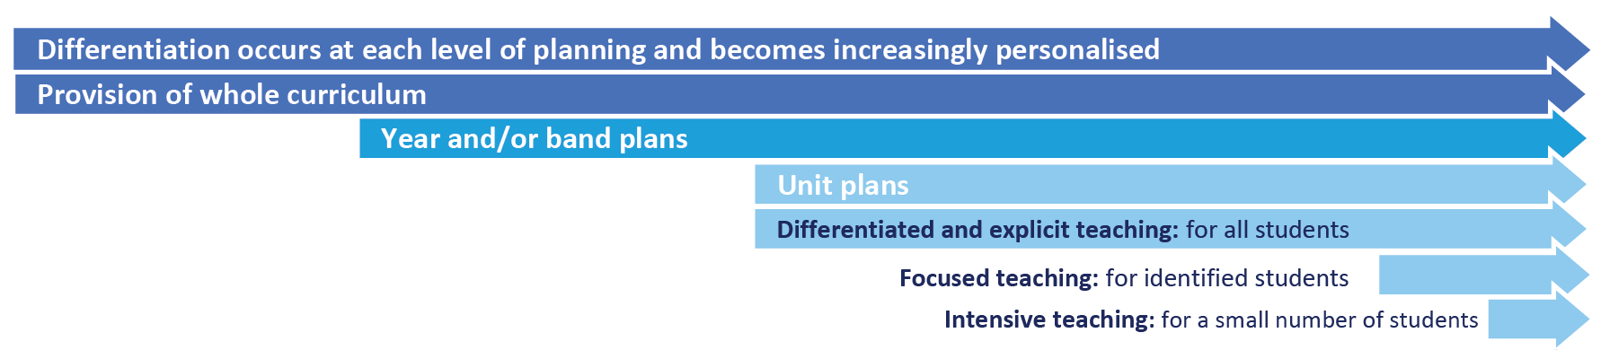

The three levels of differentiation—differentiated and explicit teaching, focused teaching, and intensive teaching—form the foundation of our behaviour and wellbeing model. This tiered approach ensures students receive the right level of support at the right time.

The First Tier: Differentiated and Explicit Teaching
All students receive high-quality, explicit instruction in behavioural expectations as part of their daily classroom experience. These expectations are:
- Taught in the same structured, scaffolded way as curriculum content
- Reinforced through modelling, practice, feedback, and correction
- Embedded in routines, transitions, and classroom procedures

Teachers use visual supports, consistent language, and age-appropriate strategies to ensure all students understand and can demonstrate expected behaviours.

Focused Teaching

The second tier is where, some students require additional teaching of behaviour skills to support their participation and success. These students may struggle with particular routines (e.g. transitions, group work) or behaviour expectations (e.g. respectful language, self-regulation) even after receiving Tier 1 support.

Focused teaching includes:
- Re-teaching key behaviour concepts
- Use of explicit, structured teaching strategies
- Targeted small-group instruction
- Opportunities for repeated practice

This support may be provided by the classroom teacher or in collaboration with staff who have expertise in learning, language, behaviour, or development.

Students receiving focused teaching are monitored for progress and may:
- Return to Tier 1 once they achieve success
- Continue in Tier 2 for extended support
- Be considered for Tier 3 if behaviour challenges persist

Evidence-informed programs used at Moonie State School to support Tier 2 instruction include:
- Positive Behaviour for Learning (PBL)
- Targeted Intervention

Intensive Teaching

The third tier, where approximately 5% of students may require frequent, individualised, and explicit instruction in behavioural skills due to complex or ongoing needs. These students may:
- Have a history of behavioural challenges
- Be affected by trauma, disability, or social-emotional needs
- Require specialised support to participate safely and successfully
Intensive teaching involves:
- One-on-one or small group sessions
- Highly structured, skill-focused instruction
- Regular review and refinement of support strategies
- Collaboration with parents, support staff, and external agencies
In some cases, students may require:
- Individual Behaviour Support Plans (BSPs)
- Functional Behaviour Assessments (FBAs)
- Personalised learning plans, wellbeing supports, and therapeutic interventions
Each student receiving Tier 3 support is assigned a case manager or mentor, who coordinates the student’s program, liaises with all stakeholders, and supports the student through regular check-ins and goal-setting.

Acknowledgement of Positive Behaviours

At Moonie State School, teaching staff and student support staff use a range of methods to consistently acknowledge and recognise positive behaviours. These methods of acknowledging student behaviours which are safe, responsible and respectful include (but are not limited to) those listed below.

- certificates presented on parade
- certificates/rewards presented in class
- whole school stickers
- behaviour chart/book records (individual and class)
- class specific award systems (eg. points, stcikers, money books)
- end of semester celebration of success activities (eg. pool party)
- attendance bear/attendance incentives
- One School records (positive behaviours)
- individualised behaviour support programs/reward systems
- verbal acknowledgement of positive behaviours
- parent contact (email/telephone) to acknowledge positive behaviours

Disciplinary Consequences

The disciplinary consequences model used at Moonie State School follows the same differentiated approach used in the proactive teaching and support of student behavioural expectations. Behaviours that require immediate intervention from administration staff are considered to be major behaviours. All other behaviours, when not consistently recurring, are considered to be minor behaviours.

The majority of students will be confident and capable of meeting established classroom expectations that are clear, explicitly taught and practised. Minor behaviours are managed in the classroom using the behaviour flowchart.

Some students will need additional support, time and opportunities to practise expected behaviours. A small percentage of the student population may experience difficulty with meeting the stated expectations, and even with focussed teaching, in-class corrective feedback, sanctions and rule reminders continue to display low-level problem behaviour. A continued pattern of low-level behaviour can interfere with teaching and learning for the whole class, and a decision may be needed by the class teacher to refer the student to the school administration team immediately for determination of a disciplinary consequence.

For a small number of students, approximately 2-5%, a high level of differentiated support or intensive teaching is required to enable them to meet the behavioural expectations. This may be needed throughout the school year on a continuous basis. The determination of the need will be made by the principal in consultation with staff and other relevant stakeholders. On occasion the behaviour of a student may be so serious, such as causing harm to other students or to staff, that the principal may determine that an out of school suspension or exclusion is necessary as a consequence for the student’s behaviour. Usually this course of action is only taken when the behaviour is either so serious as to warrant immediate removal of the student for the safety of others, and no other alternative discipline strategy is considered sufficient to deal with the problem behaviour.

The differentiated responses to problem behaviour can be organised into three tiers, with increasing intensity of support and consequences to address behaviour that endangers others or causes major, ongoing interference with class or school operations.

Differentiated Disciplinary Responses

Class teacher provides in-class or in-school disciplinary responses to low-level or minor problem behaviour. This may include:

- Pre-correction (e.g. “Remember, walk quietly to your seat”)
- Non-verbal and visual cues (e.g. posters, hand gestures)
- Whole class practising of routines
- Ratio of 5 positive to 1 negative commentary or feedback to class
- Corrective feedback (e.g. “Hand up when you want to ask a question”)
- Rule reminders (e.g. “When the bell goes, stay seated until I dismiss you”)
- Explicit behavioural instructions (e.g. “Pick up your pencil ready for learning”)
- Proximity control
- Tactical ignoring of inappropriate behaviour (not student)
- Revised seating plan and relocation of student/s
- Individual positive reinforcement for appropriate behaviour
- Classwide incentives
- Reminders of incentives or class goals
- Redirection
- Low voice and tone for individual instructions
- Give 30 second ‘take-up’ time for student/s to process instruction/s
- Reduce verbal language
- Break down tasks into smaller chunks
- Provide positive choice of task order (e.g. “Which one do you want to start with?”)
- Prompt student to take a break or time away in class
- Model appropriate language, problem solving and verbalise thinking process (e.g. “I’m not sure what is the next step, who can help me?”)
- Provide demonstration of expected behaviour
- Peer consequence (e.g. corrective feedback to influential peer demonstrating same problem behaviour)
- Private discussion with student about expected behaviour
- Reprimand for inappropriate behaviour
- Warning of more serious consequences (e.g. removal from classroom)
- Time-out in a buddy classroom
- Time-out (Principal’s office)
- Loss of play time
- Parent contact/meeting to discuss behaviours of concern
- OneSchool Record (behaviour tab)

Focused Disciplinary Responses

Class teacher is supported by other school-based or non-school based staff to address problem behaviours. This may include:

- Functional Behaviour Assessment
- Individual student behaviour support strategies (e.g. Individual Student Behaviour Plan)
- Targeted skills teaching in small group
- Behavioural contract
- Supported play plan
- Counselling and guidance support
- Self-monitoring plan
- Check in/ Check Out strategy (at the beginning and the end of the school day)
- Teacher coaching and debriefing
- Referral to Student Support Network for team based problem solving
- OneSchool record (behaviour tab)
- Stakeholder meetings with parents and external agencies

Intensive Disciplinary Responses

School staff work can work in consultation with the Student Support Services Network to address persistent or ongoing serious problem behaviour. This may include:

- OneSchool records (Individual Support Plan)
- Functional Behaviour Assessment based individual support plan
- Complex case management and review
- Stakeholder meeting with parents and external agencies including regional specialists
- Temporary removal of student property (e.g. mobile phone)
- Short term suspension (up to 10 school days)
- Long term suspension (up to 20 school days)
- Charge related suspension (student has been charged with a serious criminal offence is suspended from school until the charge has been dealt with by the relevant justice authorities)
- Suspension pending exclusion (student is suspended from school pending a decision by the Director-General or delegate (principal) about their exclusion from school)
- Exclusion (student is excluded from a particular state school site, a group of state schools or all state schools in Queensland for a defined period of time or permanently)
- Cancellation of enrolment for students older than compulsory school age who refuse to participate in the educational program provided at the school.

School Disciplinary Absences

A School Disciplinary Absence (SDA) is an enforced period of absence from attending a Queensland state school, applied by the Principal as a consequence to address certain categories of student behaviour. There are four types of SDA:
- Short suspension (1 to 10 school days)
- Long suspension (11 to 20 school days)
- Charge-related suspension
- Exclusion (period of not more than one year or permanently).

At Moonie State School, the use of any SDA is considered a very serious decision. It is typically only used by the Principal when other options have been exhausted or the student’s behaviour is so dangerous that continued attendance at the school is considered a risk to the safety or wellbeing of the school community.

Parents and students may appeal a long suspension, charge-related suspension or exclusion decision. A review will be conducted by the Director-General or their delegate, and a decision made within 40 schools days to confirm, amend/vary or set aside the original SDA decision by the Principal.

The appeal process is a thorough review of all documentation associated with the SDA decision and provides an opportunity for both the school and the family to present their case in the matter. Time is afforded for collection, dissemination and response to the materials by both the school and the family. It is important that the purpose of the appeal is understood so that expectations are clear, and appropriate supports are in place to ensure students can continue to access their education while completing their SDA.

Re-entry following suspension

Students who are suspended from Moonie State School may be invited to attend a re-entry meeting on the day of their scheduled return to school. The main purpose of this meeting is to welcome the student, with their parent/s, back to the school. It is not a time to review the student’s behaviour or the decision to suspend, the student has already received a punishment through their disciplinary absence from school. The aim of the re-entry meeting is for school staff to set the student up for future success and strengthen home-school communication.

Arrangements

The invitation to attend the re-entry meeting will be communicated via telephone and in writing, usually via email. Re-entry meetings are short, taking less than 10 minutes, and are kept small with only the Principal or their delegate attending with the student and their parent/s.

A record of the meeting is saved in OneSchool, under the Contact tab, including any notes or discussions occurring during the meeting.

Structure

The structure of the meeting should follow a set agenda, shared in advance with the student and their family. If additional items are raised for discussion, a separate arrangement should be made to meet with the parent/s at a later date and time. This meeting should be narrowly focussed on making the student and their family feel welcome back into the school community.

Possible agenda:

- Welcome back to school
- Check in on student wellbeing
- Discuss any recent changes to school routine or staffing
- Offer information about supports available (e.g. guidance officer)
- Set a date for follow-up
- Thank student and parent/s for attending
- Walk with student to classroom

Reasonable adjustments

In planning the re-entry meeting, school staff will consider reasonable adjustments needed to support the attendance and engagement of the student. This includes selecting an appropriate and accessible meeting space, organising translation or interpretation services or supports (e.g. AUSLAN), provision of written and/or pictorial information and other relevant accommodations. The inclusion of support staff, such as guidance officers or Community Education Counsellors, may also offer important advice to ensure a successful outcome to the re-entry meeting.

School Policies

Moonie State School has tailored school discipline policies designed to ensure students, staff and visitors work cooperatively to create and maintain a supportive and safe learning environment. Please ensure that you familiarise yourself with the responsibilities for students, staff and visitors outlined in the following policies:

- Temporary removal of student property
- Use of mobile phones and other devices by students
- Preventing and responding to bullying
- Appropriate use of social media

Temporary Removal of Student Property

The removal of any property in a student’s possession may be necessary to promote the caring, safe and supportive learning environment of the school, to maintain and foster mutual respect between all state school staff and students. The Temporary removal of student property by school staff procedure outlines the processes, conditions and responsibilities for state school principals and school staff when temporarily removing student property.

In determining what constitutes a reasonable time to retain student property, the principal or state school staff will consider:

- the condition, nature or value of the property
- the circumstances in which the property was removed
- the safety of the student from whom the property was removed, other students or staff members
- good management, administration and control of the school.

The Principal or state school staff determine when the temporarily removed student property can be returned, unless the property has been handed to the Queensland Police Service.

The following items are explicitly prohibited at Moonie State School and will be removed if found in a student’s possession:

- illegal items or weapons (e.g. guns, knives*, throwing stars, brass knuckles, chains)
- imitation guns or weapons
- potentially dangerous items (e.g. blades, rope)
- drugs** (including tobacco and alcohol)
- aerosol deodorants or cans (including spray paint)
- explosives (e.g. fireworks, flares, sparklers)
- flammable solids or liquids (e.g. fire starters, mothballs, lighters)
- poisons (e.g. weed killer, insecticides)
- inappropriate or offensive material (e.g. racist literature, pornography, extremist propaganda).

* No knives of any type are allowed at school, including flick knives, ballistic knives, sheath knives, push daggers, trench knives, butterfly knives, star knives, butter knives, fruit knives or craft knives, or any item that can be used as a weapon. In circumstances where students are required to have their own sharp tools for particular subjects or vocational courses, the school will provide information about the procedures for carrying and storing these items at school.

Responsibilities

School Staff (at Moonie State School)

- do not require the student’s consent to search school property such as lockers, desks or laptops that are supplied to the student through the school;
- may seize a student’s bag where there is suspicion that the student has a dangerous item (for example, a knife) in their school bag, prior to seeking consent to search from a parent or calling the police;
- consent from the student or parent is required to examine or otherwise deal with the temporarily removed student property. For example, staff who temporarily remove a mobile phone from a student are not authorised to unlock the phone or to read, copy or delete messages stored on the phone;
- there may, however, be emergency circumstances where it is necessary to search a student’s property without the student’s consent or the consent of the student’s parents (e.g. to access an EpiPen for an anaphylactic emergency);
- consent from the student or parent is required to search the person of a student (e.g. pockets or shoes). If consent is not provided and a search is considered necessary, the police and the student’s parents should be called to make such a determination.

Parents of students (at Moonie State School)

- ensure your children do not bring property onto schools grounds or other settings used by the school that:
  - is prohibited according to this Student Code of Conduct
  - is illegal or puts the safety or wellbeing of others at risk
  - does not preserve a safe, supportive or productive learning environment
  - does not maintain and foster mutual respect

Parents should collect temporarily removed student property as soon as possible after they have been notified by the Principal or state school staff that the property is available for collection.

Students of Moonie State School:

- do not bring property onto school grounds or other settings used by the school (e.g. camp, sporting venues) that:
  - is prohibited according to the Moonie State School Code of Conduct
  - is illegal
  - puts the safety or wellbeing of others at risk
  - does not preserve a caring, safe, supportive or productive learning environment
  - does not maintain and foster mutual respect;
Students should collect their property as soon as possible when advised by the Principal or state school staff it is available for collection.

Use of mobile phones and other devices by students

Digital literacy refers to the skills needed to live, learn and work in a society where communication and access to information is dominated by digital technologies like mobile phones. However, the benefits brought about through these diverse technologies can be easily overshadowed by deliberate misuse which harms others or disrupts learning.

This policy reflects the importance the school places on students displaying courtesy, consideration and respect for others whenever they are using personal technology devices.

Mobile Phones

Any mobile phones brought to school are to be clearly labelled and given to front office staff at the beginning of the day and are to be collected at the end of the school day. All care but no responsibility will be taken for equipment.

Confiscation

Permitted personal technology devices used contrary to this policy on school premises will be confiscated by school staff. They will be made available for collection from the school office at the end of the school day unless required to be kept for purposes of disciplinary investigation, when it will only be returned in the presence of a parent.

Devices potentially containing evidence of criminal offences may be reported to the police. In such cases police may take possession of such devices for investigation purposes and students and parents will be advised to contact Queensland Police Service (QPS) directly.

Students who have a personal technology device confiscated more than once will not be permitted to have a personal technology device at school for at least one month, or longer if deemed necessary by the Principal.

Personal Technology Device Etiquette

Bringing personal technology devices to school is not encouraged by the school because of the potential for theft and general distraction and/or disruption associated with them. However, if they are brought to school, they must be turned off and out of sight during assemblies or classes unless given permission from teaching staff.

Recording Voice and Images

Every member of the school community should feel confident about participating fully and frankly in all aspects of school life without concern that their personal privacy is being invaded by them being recorded without their knowledge or consent.

We uphold the value of trust and the right to privacy at Moonie State School. Students using personal technology devices to record inappropriate behaviours or incidents (such as vandalism, fighting, bullying, staged fighting or pranks etc) for the purpose of dissemination among the student body or outside the school, by any means (including distribution by phone or internet posting) builds a culture of distrust and disharmony.

Students must not record images anywhere that recording would not reasonably be considered appropriate (e.g. in change rooms, toilets or any other place where a reasonable person would expect to be afforded privacy).

Recording of events in class is not permitted unless express consent is provided by the class teacher.

A student at school who uses a personal technology device to record private conversations, ordinary school activities (apart from social functions like graduation ceremonies) or violent, illegal or embarrassing matter capable of bringing the school into public disrepute is considered to be in breach of this policy.

Even where consent is obtained for such recording, the school will not tolerate images or sound captured by personal technology devices on the school premises or elsewhere being disseminated to others, if it is done for the purpose of causing embarrassment to individuals or the school, for the purpose of bullying or harassment, including racial and sexual harassment, or where without such intent a reasonable person would conclude that such outcomes may have or will occur.

Students involved in:

• recording; and/or
• disseminating material (through text messaging, display, internet uploading etc); and/or,
• knowingly being a subject of a recording

Breach of this policy may be subject to discipline (including suspension and recommendation for exclusion).

Students should note that the recording or dissemination of images that are considered indecent is against the law and if detected by the school will result in a referral to QPS.

Text Communication

The sending of text messages that contain obscene language and/or threats of violence may amount to bullying and or harassment or even stalking, and will subject the sender to discipline and possible referral to QPS. Students receiving such text messages at school, should ensure they keep the message as evidence and bring the matter to the attention of the school administration.

Recording Private Conversations and the Invasion of Privacy Act 1971

It is important that all members of the school community understand that under the Invasion of Privacy Act 1971, ‘a person is guilty of an offence against this Act if the person uses a listening device to overhear, record, monitor or listen to a private conversation’. It is also an offence under the Act for a person who has overheard, recorded, monitored or listened to a conversation to which s/he is not a party to publish or communicate the substance or meaning of the conversation to others.

Students need to understand that some conversations are private and therefore to overhear, record, monitor or listen to such private conversations may be in breach of this Act, unless consent to the recording is appropriately obtained.

Special Circumstances Arrangement

Students who require the use of a personal technology device in circumstances that would contravene this policy (for example to assist with a medical condition or other disability or for a special project) should negotiate a special circumstances arrangement with the Deputy Principal or Principal.

* Personal Technology Devices includes, but is not limited to, games devices (such as
Portable gaming devices, Tamagotchis®, laptop computers, PDAs, Blackberrys®,
cameras and/or voice recording devices (whether or not integrated with a mobile phone
or MP3 player), mobile telephones, IPods® and devices of a similar nature.

Preventing and Responding to Bullying

What is Bullying?

Bullying involves a series of hurtful actions by the bully to the victim over a period of time. Those actions may be verbal (such as name-calling, teasing), physical (punching), psychological (sending to Coventry, spreading rumours) and threats (extorting money) and usually the victim has difficulty in coping with such attacks (Finger, 1993).

Purpose

Moonie State School strives to create positive, predictable environments for all students at all times of the day. The disciplined, supportive teaching environment that we are creating is essential to:

o achieving overall school improvement, including the effectiveness and efficiency of our
student support procedures
o raising achievement and attendance
o promoting equality and diversity and
o ensuring the safety and well-being of all members of the school community.

At Moonie State School we aim to prevent and respond to bullying and cyberbullying. Research indicates that both those being bullied and those who bully are at risk for behavioural, emotional and academic problems. These outcomes are in direct contradiction to our school community’s goals and efforts for supporting all students.

Bullying behaviours that will not be tolerated at Moonie State School include name-calling, taunting, mocking, making offensive comments, kicking, hitting, pushing, taking belongings, inappropriate text messaging, sending offensive or degrading images by phone or internet, producing offensive graffiti, gossiping, excluding people from groups, and spreading hurtful and untruthful rumours.

Bullying behaviours may be related to:

o race, religion or culture
o disability
o appearance or health conditions
o sexual orientation
o sexist or sexual language
o young carers or children in care.

At Moonie State School there is broad agreement among students, staff and parents that
bullying is observable and measurable behaviour. When considering whether or not bullying has occurred, we will therefore avoid speculation on the intent of the behaviour, the power of individuals involved, or the frequency of its occurrence. Whether bullying behaviour is observed between students of equal or unequal power, whether it occurs once or several times, and whether or not the persons involved cite intimidation, revenge, or self-defence as a motive, the behaviour will be responded to in similar fashion, that is, as categorically unacceptable in the school community.

Procedures for Preventing and Responding to Incidents of Bullying
(including Cyber-bullying)

Rationale

• Research indicates that many problem behaviours are peer-maintained. That is, peers react to bullying in ways that may increase the likelihood of it occurring again in the future. Reactions include joining in, laughing, or simply standing and watching, rather than intervening to help the person being bullied. Whilst our school would never encourage students to place themselves at risk, our anti-bullying procedures involve teaching the entire
school a set of safe and effective response to all problem behaviour, including bullying, in such a way that those who bully are not socially reinforced for demonstrating it.

• The anti-bullying procedures at Moonie State School are an addition to our already research-validated school-wide positive behaviour support processes. This means that all students are being explicitly taught the expected school behaviours and receiving high levels of social acknowledgement for doing so. Adding lessons on bullying and how to prevent and respond to it is a subset of procedures that our students are already accustomed to.

Prevention

• Attempting to address specific problem behaviours will not be successful if the general level of disruptive behaviour in all areas of our school is not kept to a low level. Therefore, our school-wide universal behaviour support practices will be maintained at all times.

o Our universal behaviour support processes will always remain the primary strategy for preventing problem behaviour, including preventing the subset of bullying behaviour.
All students know the school rules and have been taught the expected behaviours.

o All students have been or are being taught the specific routines in the non-classroom areas, from exiting the classroom, conducting themselves in accordance with the school expectations in the playground and other areas, to re-entering their classrooms.

o All students are receiving high levels of positive reinforcement for demonstrating expected behaviours, including those associated with following our routines, from all staff in the non-classroom areas of the school

o A high level of quality active supervision is a permanent staff routine in the non-classroom areas. This means that duty staff members are easily identifiable and are constantly moving, scanning and positively interacting as they move through the designated supervision sectors of the nonclassroom areas.

Research indicates that a common outcome of anti-bullying programming is an improvement in understanding of bullying but little change in the frequency are nature of actual bullying behaviour. One of the reasons cited for this outcome is the lack of behavioural rehearsal in the programming. The antibullying process at Moonie State School takes care to combine knowledge with practice in a process of active learning, so that students understand by ‘doing’ as much as by ‘knowing’.

Bullying is seen as a threat to the rights of the members of Moonie State School Community and is unacceptable behaviour. To ensure Bullying is monitored, a whole school approach to the issue is required.

Responsibility of the School

-  Implementing the School’s Student Code of Conduct
-  Active class and playground supervision by staff
-  Class discussions to deal with problem behaviours
-  Individual discussion with staff or Behaviour Management Support Teacher or
counselling with the Guidance Officer
-  Teaching of the anti-bullying elements within social skills programs
-  Teaching strategies to students to help them deal with bullying

Responsibility of Parents

What Can Parents Do?

-  WATCH FOR SIGNS that your child is being bullied, e.g., unwillingness to walk to
or from school, worries about coming to school, unexplained bruising,
disappearance of property, etc.
-  ENCOURAGE the child to talk it through as much as possible so you get the basic
act
-  KEEP AN OPEN MIND, remembering you are getting one side of the story only
-  ASK questions gently
-  HELP the child reflect on what has been done so far
-  HELP the child work out the best way of solving the problem

 
Some Important Next Steps to Consider:

-  NEVER try to sort out the bullies yourself – it rarely works and can make the
situation worse
-  WHEN YOU ARE CLEAR on the facts contact your child’s teacher for an interview
-  PRESENT your information as calmly as possible
-  REMEMBER, the school says NO to bullying and the best way to solve the
problem is to work with the school as partners in finding solutions
-  ASK your child’s teacher about the school’s policy on bullying and how they
deal with it in their classroom
- GIVE the teacher some time to investigate the problem and arrange a follow up
time
 
The Next Steps May Then Include:

-  ENCOURAGE your child to develop friendships
-  SUPPORT your child in developing sporting, cultural and other talents that will
build their confidence in a safe, supportive environment
-  WORK at improving your child’s self esteem
-  SEEK counselling to enable the child to learn to be more assertive and resilient
and less likely to be bullied
-  IF SEVERE ABUSE is evident, you may wish to consider police action

Responsibilities of the Teacher in regards to Bullying

-  Make yourself available
-  Treat incidents confidentially where necessary
-  Treat incidents seriously
-  Thoroughly investigate each incident
-  Follow-up where necessary
-  Proactively educate the children using social skills lessons/programs
- Record incidents of bullying related behaviours on One School

Rights of Children with Respect to Bullying at School

1. To know that they may talk in confidence to a liked and trusted Teacher/Administration
team member about an incident/s and that they will be listened to and taken seriously.
2. To know that help is available.
3. To be confident that follow-up action will occur after reporting the bullying.
4. That assistance will be given to help them deal successfully with any further bullying.

Responsibilities of Students
At Moonie State School, students are taught The High Five Strategy from Kindy to Grade 6 to allow them to manage bullying and/or situations they feel uncomfortable as a result of another person’s behaviours. This also supports them to develop resilience necessary not only in school life, but in life as an adult. Staff understand the requirement to act diligently and in a timely manner when a student makes a report to them. All staff are easily identifiable when rostered to provide supervision to assist students when reporting.

High Five Steps include:

- Ignore
- Walk away
- Speak friendly
- Speak firmly
- Report

Responsibilities of Children Who Witness Incidents of Bullying:

As most bullying occurs in the playground, student involvement is essential.
Students are more likely to be aware of and be witnesses of bullying.

Students can:
- Inform teachers of places in the school grounds (eg behind the toilets) where
bullying occurs.
- Inform the classroom teacher or playground duty teacher where children are
being bullied.

Witness incidents of bullying and report:
1. Who was bullying
2. Who was being bullied
3. What happened
4. Where the incident took place
5. Offer support and friendship to the child who has been bullied

Appropriate Use of Social Media

Cyberbullying is treated at Moonie State School with the same level of seriousness as in-person bullying. The major difference with cyberbullying however, is that unlike in-person bulling, cyberbullying follows students into their community, their homes and their bedrooms, giving them no opportunity to escape the harassment or abuse during the evening, weekends or holidays.

In the first instance, students or parents who wish to make a report about cyberbullying should approach the regular class teacher.

It is important for students, parents and staff to know that state school principals have the authority to take disciplinary action to address student behaviours that occur outside of school hours or school grounds. This includes cyberbullying. Parents and students who have concerns about cyberbullying incidents occurring during school holidays should immediately seek assistance through the Office of the e-Safety Commissioner or the Queensland Police Service.

Students enrolled at Moonie State School may face in-school disciplinary action, such as detention or removing of privileges, or more serious consequences such as suspension or exclusion from school for engaging in behaviour that adversely affects, or is likely to adversely affect, other students or the good order and management of the school. This includes behaviour such as cyberbullying which occurs outside of school hours or settings, for example on the weekend or during school holidays. It also applies to inappropriate online behaviour of enrolled students that is directed towards other community members or students from other school sites.

Parents or other stakeholders who engage in inappropriate online behaviour towards students, staff or other parents may be referred to the Office of the e-Safety Commissioner and/or the Queensland Police Service. State school staff will be referred for investigation to the Integrity and Employee Relations team in the Department of Education.

Cyberbullying response flowchart for school staff

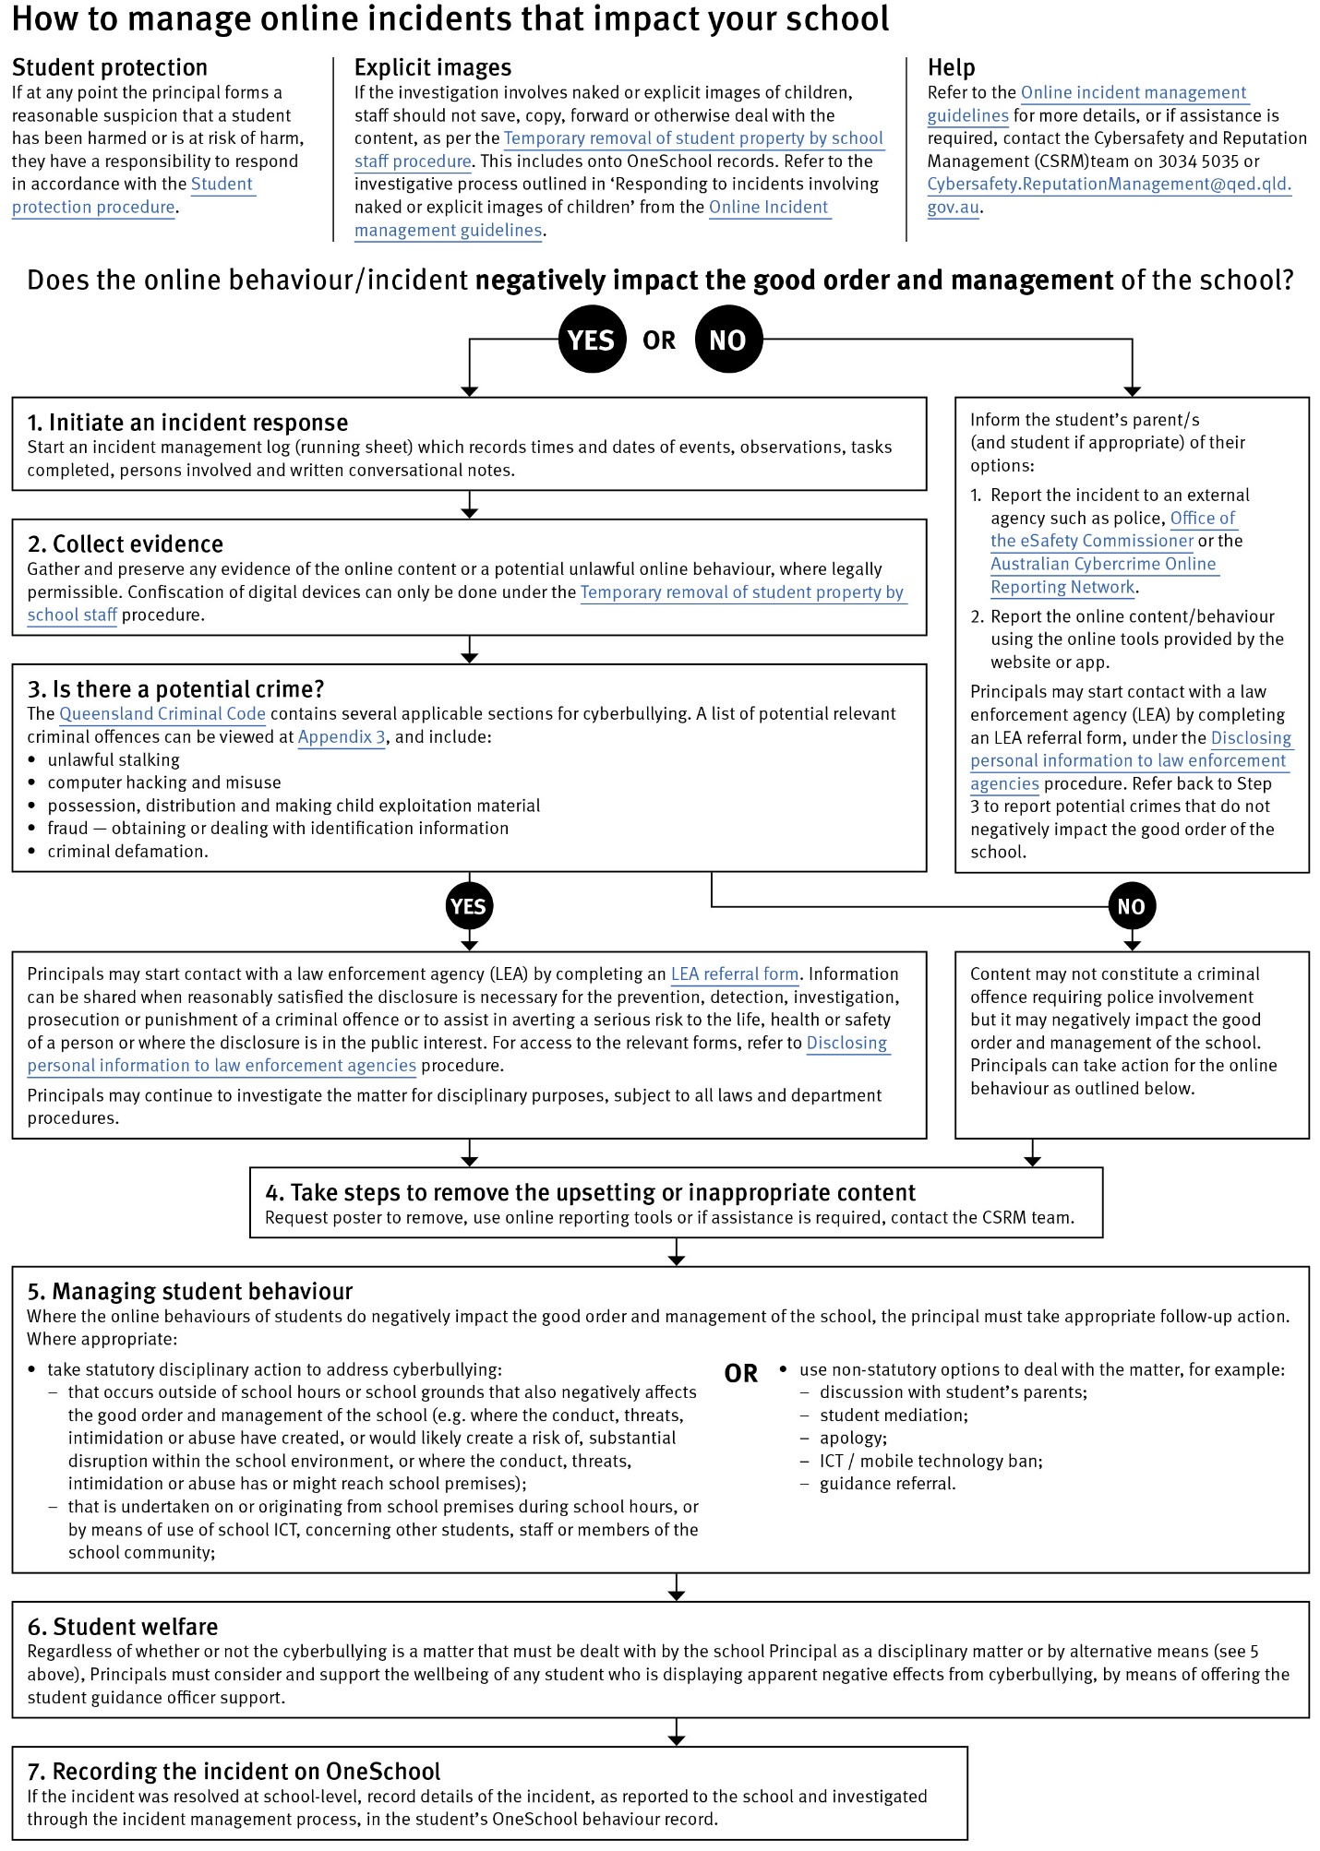

Restrictive Practices

School staff at Moonie State School need to respond to student behaviour that presents a risk of physical harm to the student themselves or others. It is anticipated that most instances of risky behaviour can be de-escalated and resolved quickly. In some rarer situations, where there is immediate risk of physical harm to the student or other people, and when all other alternative strategies have failed to reduce the risk, it may be necessary for staff to use restrictive practices.

The use of restrictive practices will always be as a last resort, when there is no other available option for reducing immediate risk to the student, staff or other people. Restrictive practices are not used for punishment or as a disciplinary measure.

The department’s Restrictive practices procedure is written with consideration for the protection of everyone’s human rights, health, safety and welfare. There are six fundamental principles:

- Regard to the human rights of those students
- Safeguards students, staff and others from harm
- Ensures transparency and accountability
- Places importance on communication and consultation with parents and carers
- Maximises the opportunity for positive outcomes, and
- Aims to reduce or eliminate the use of restrictive practices.

Very rarely restrictive practices will be planned and staff will employ, when necessary, pre-arranged strategies and methods (of physical restraint/ mechanical restraint/ clinical holding) which are based upon behaviour risk assessment or clinical health need and are recorded in advance. The use of planned strategies will only be where there is foreseeable immediate risk consistent with the Restrictive practices procedure.

Seclusion will not be used as a planned response and will only be used in serious circumstances for managing an unforeseeable situation in an emergency. It will be used for the shortest time possible and in a safe area that presents no additional foreseeable risk to the student. In such emergencies, a staff member will observe the student at all times and seclusion will cease as soon as possible.

Following the use of any restrictive practice, a focused review will help staff to understand how they responded to the risk in any incident that involved the use of a restrictive practice. Staff will consider whether there are other options for managing a similar situation in the future. This strategy works well for reducing the use of restrictive practices.

All incidents of restrictive practices will be recorded and reported in line with departmental procedures.

Critical Incidents

It is important that all school staff have a consistent understanding of how to respond in emergencies involving student behaviour that seriously endangers the student or others. This consistency ensures that appropriate actions are taken to ensure that both students and staff are kept safe.

A critical incident is defined as an occurrence that is sudden, urgent, and usually unexpected, or an occasion requiring immediate action (e.g. in the community, on the road). The aim in these situations is to bring the behaviour of the student under rapid and safe control. It is not a time to try and to punish or discipline the student; it is a crisis management period only.

Staff should follow the documented plan for any student involved in regular critical incidents, which should be saved and available for staff to review in OneSchool.

For unexpected critical incidents, staff should use basic defusing techniques:

- Avoid escalating the problem behaviour: Avoid shouting, cornering the student, moving into the student’s space, touching or grabbing the student, sudden responses, sarcasm, becoming defensive, communicating anger and frustration through body language.

- Maintain calmness, respect and detachment: Model the behaviour you want students to adopt, stay calm and controlled, use a serious measured tone, choose your language carefully, avoid humiliating the student, be matter of fact and avoid responding emotionally.

- Approach the student in a non-threatening manner: Move slowly and deliberately toward the problem situation, speak privately to the student/s where possible, speak calmly and respectfully, minimise body language, keep a reasonable distance, establish eye level position, be brief, stay with the agenda, acknowledge cooperation, withdraw if the situation escalates.

- Follow through: If the student starts displaying the appropriate behaviour briefly acknowledge their choice and re-direct other students’ attention towards their usual work/activity. If the student continues with the problem behaviour, then remind them of the expected school behaviour and identify consequences of continued unacceptable behaviour.

Debrief: At an appropriate time when there is low risk of re-escalation, help the student to identify the sequence of events that led to the unacceptable behaviour, pinpoint decision moments during the sequence of events, evaluate decisions made, and identify acceptable decision options for future situations.

Resources
- Australian Professional Standards for Teachers

- Bullying. No Way!

- eheadspace

- Kids Helpline

- Office of the eSafety Commissioner

- Parent and community engagement framework

- Parentline

- Queensland Department of Education School Discipline

- Raising Children Network

- Student Wellbeing Hub

APPENDIX

APPENDIX 1 – Tiered Levels of Support

Tier | Prevention Description
1 | All students (100%) in the school receive support for their academic and behavioural development. Focus is on the whole-school implementation of both the Australian Curriculum and Positive Behaviour for Learning (PBL) expectations.  This involves:  - teaching behaviours in the setting they will be used  - being consistent when addressing challenging behaviour, while taking developmental norms and behavioural function into account  - providing refresher lessons and targeted recognition throughout the school year so skills are ready and likely to be used when students need them  - asking students and their families for their perspectives on school climate, instruction, reinforcement, and discipline so improvements in Tier 1 may be made.
2 | Targeted instruction and supports for some students are more intense than Tier 1 services, providing more time and specialisation in services from a range of school-based staff to enable students to meet the required academic and behavioural standards.  Tier 2 supports build on the lessons provided at Tier 1, and may prevent the need for more intensive interventions. Tier 2 supports are provided to small groups of students with similar needs, offering more time and/or detailed instruction on the Australian Curriculum or particular aspects of Positive Behaviour for Learning (PBL) expectations. The types of interventions offered at this level will vary according to the needs of each school’s student body, but all have certain things in common:  - there is a clear connection between the skills taught in the interventions and the school-wide expectations.  - interventions require little time of classroom teachers and are easy to sustain  - variations within each intervention are limited  - interventions have a good chance of working (e.g., they are ‘evidence-based’ interventions that are matched to the student’s need).  If the school data indicates that more than 10-15% of students require targeted services, then a review of Tier 1 is needed to address the basic implementation and quality of instruction.
3 | Individualised services for few students (usually less than 5%) who require the most intensive support a school can provide. These are usually delivered in very small groups or on an individual basis.  Tier 3 supports continue to build on the lessons and supports provided at Tiers 1 and 2, becoming more individualised and more intensive until teams can identify what is needed for a student to be successful. Tier 3 supports are based on the underlying reasons for a student’s behaviour (their FBA) and should include strategies to:  - PREVENT problem behaviour  - TEACH the student an acceptable replacement behaviour  - REINFORCE the student’s use of the replacement behaviour  - MINIMISE the consequences for problem behaviour.  Tier 3 supports exist along a continuum. Many students can benefit from a simple (or brief) Functional Behaviour Assessment (FBA) that identifies unique strategies to help the student achieve success. A smaller percentage of students may require a more comprehensive FBA that includes a more thorough process for data collection, teaming, and problem solving. A much smaller percentage of students may need an intensive FBA and wraparound plan that includes personnel from outside agencies and rigorous problem solving procedures.  If the school data indicates that more than 2-5% of the student population requires individualised services, a review of Tier 1 and Tier 2 supports and organisation are recommended.

